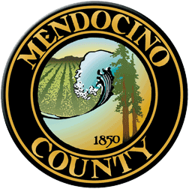

COVID19 Business Specific Health & Safety Form

TRANSIENT LODGING

NOTE: In order to self-certify compliance at www.mendocinocountybusiness.org, you must read and implement the County of Mendocino-specific guidelines for Transient Lodging, including short-term vacation rentals, issued in the June 12, 2020 Public Health Order.
In order to fill out this form and create a health and safety plan for your business, refer to the State of California Guidelines for Transient Lodging and the County of Mendocino Public Health Order dated June 12, 2020. A health and safety plan is required to operate.

- Describe the type of signage you will have and locations.
- Describe the PPE you will provide to your employees and guests.
- Describe your plans for training employees and temporary workers on the use of PPE; disinfection; sanitation and other cleaning techniques.
- Describe your plans for protecting your employees' health.
- Describe your plans for protecting the health of guests.
- Describe how you will prevent crowds gathering at your facility.
- Describe how your will enforce physical distancing at your facility.
- Describe the payment methods you will use (contactless is preferred).
- Provide the name, phone number and email address (optional) of the person or persons you have designated as the COVID19 contacts for your property. In your response, state whether they are on-site or available within one hour of a call.
- Reservations are required. What are your methods for taking reservations and appointments?
- Describe the limit on the number of guests permitted in each room, unit, or vacation rental (regardless of size).
- Describe the occupancy limitations for your hotel or vacation rental.
- How many hours are necessary between separate room or unit occupancies on your property?
- Describe the signed agreement you have with guests regarding compliance with County of Mendocino Public Health Orders.
- In the event your facility has a guest who contracts Covid-19, what are your plans for quarantine and isolation?
- If your property has a sauna, hot tub or steam room, is it operational?

Your Business Specific Health & Safety Plan will become public record.

