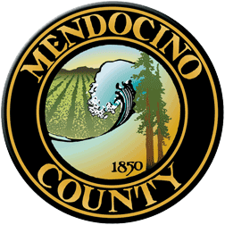

COVID19 Business Specific Health & Safety Form

GYMS and FITNESS CENTERS

NOTE: In order to self-certify compliance at www.mendocinocountybusiness.org, you must read and implement the County of Mendocino-specific guidelines for Campgrounds, RV Parks and Outdoor Recreation issued in the June 12, 2020 Public Health Order.
In order to fill out this form and create a health and safety plan for your business, refer to the State of California Guidelines for Gyms and Fitness Centers and the County of Mendocino Public Health Order dated June 12, 2020. A health and safety plan is required to operate.

- Describe the type of signage you will have and locations.
- Describe the PPE you will provide to your employees and clients.
- Describe your plans for training employees and temporary workers on the use of PPE; disinfection; sanitation and other cleaning techniques.
- Describe your plans for protecting your employees' health
- Describe your plans for protecting the health of clients.
- Describe how you will prevent crowds gathering at your facility.
- Describe how you will enforce physical distancing at your facility.
- Describe the payment methods you will use (contactless is preferred).
- Describe your methods for cleaning and disinfecting locker rooms and shower facilities and the types of cleaning products you will be using.
- How will you maintain physical distancing in shower and locker rooms?
- Describe how you will ensure sanitary conditions in multi-stall restrooms.
- If your facility has a snack area, describe the measures you will take to ensure the safety of clients and employees.
- If your facility has a retail area, describe the measures you will take to ensure the safety of clients and employees.
- Describe the measures you will take to clean swimming pools and surrounding areas.

Your Business Specific Health & Safety Plan will become public record.

