Mendocino County Covid-19 Health & Safety Form
for Tasting Rooms and Bars

McFadden’s Blue Quail Tasting Room
13275 South Highway 101, No 5
Hopland, CA 95449
(707) 744-8463

1.Describe the type of signage you will have and locations.
We have this sign on the front and back doors:
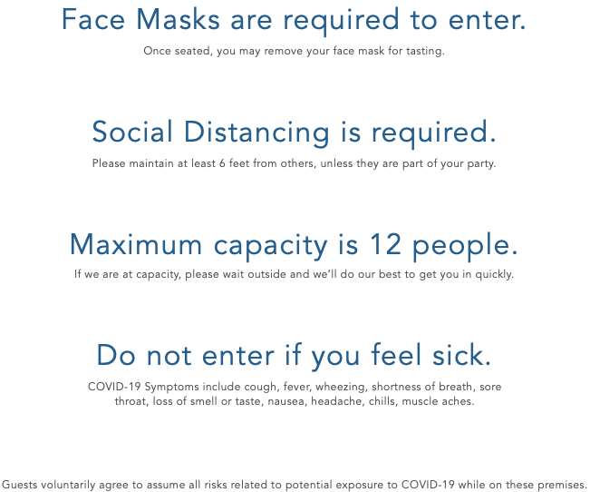
We also have a sign on our retail display rack asking customers only to touch what they plan to purchase.

2. Describe the PPE you will provide to your employees and guests.
We provide employees with disposable face masks and gloves, though for the most part they bring their own. For customers, we have face masks available for purchase and several hand sanitizer stations throughout the Tasting Room.

3. Describe your plans for training employees and temporary workers on the use of PPE; disinfection; sanitation and other cleaning techniques.
Our Health & Safety Protocol is attached at the end of this questionnaire and we have gone through it line by line with our one Tasting Room employee. We have also done a walk-through at the Tasting Room to be sure she knows where additional cleaning supplies are, how to properly space out guests, how to sanitize and clean and to answer any questions about this new method of doing things.

4. Describe your plans for protecting your employees' health.
Because of our small space, we are only scheduling one employee at a time until further safety measures are lifted. We require facemasks for all persons entering our Tasting Room. We have clear signage on the doors stating the rules of operation. We have signage asking customers to only touch what they plan to purchase. We have multiple hand sanitizing stations throughout. We have tape markings on the floor designating proper social distancing. We have multiple seating areas that are 6’ apart. When weather permits, we leave doors and windows open to provide better air flow.

5. Describe your plans for protecting the health of clients and guests.
We require facemasks for all persons entering our Tasting Room, though guests may remove them once they are seated and have placed their order. We no longer offer self-serve water, instead our staff will bring water as requested. We wash and sanitize all glassware and dump buckets after each use. We thoroughly clean and sanitize areas touched by a customer once they have left so it’s safe for the next person. We only allow 12 customers in at a time, with a maximum of 5 parties seated at least 6’ apart from one another. We have clear signage on the doors stating the rules of operation. We have signage asking customers to only touch what they plan to purchase. We have multiple hand sanitizing stations throughout. We have tape markings on the floor designating social distancing. When weather permits, we leave doors and windows open to provide better air flow.

6. Describe how you will prevent crowds gathering at your facility.
The maximum capacity at our Tasting Room is 12 customers and 1 employee. If we do meet that capacity at any time, guests will be seated at areas that are at least 6’ apart. If we have 12 people already in the Tasting Room other guests will be asked to wait outside until there is room for them.

7. Describe how you will enforce physical distancing at your facility.
We will have 5 seating areas for customers that are all at least 6’ apart: 2 tables under each window with room for 2 each, a space at the bar for 2 people to stand, the couch area with room for 6, and a high-top table with room for 4. Not all spaces can be full at once, we will only allow 12 guests at any given time and will show them to a designated seating area before we serve them so they aren’t inclined to wonder.

8. Describe the payment methods you will use (contactless is preferred).
We use an iPad for payment processing and wipe it down between each use. The customer credit card is only handled by that customer when they insert it into the card reader, our staff does not need to handle it. We also take cash and checks but encourage credit cards. If a customer does use cash or check our employee will wash their hands before changing tasks.

9. What are your hours of Operation: AM to PM.
We’re open Monday, Thursday and Friday from 12-6pm, and Saturday and Sunday from 11am-6pm. But tastings only happen until 5pm, after that it’s retail sales only.

10. Reservations are required. What are your methods for taking reservations and appointments?
We have a sign-in appointment sheet that all guests are required to fill out when they enter. It asks for the name, phone/email, appointment date and time of EVERY member in a party.

11. Describe your plans for utilizing outdoor areas to promote social distancing.
We do not have outdoor seating, but we will use outdoor areas to ask guests to wait if we are at our 12 person capacity.

12. Describe your system for providing menus to clients. (Menus must be disposable, digitally available or made viewable from video screens or "no touch" pads.)
Our menus are disposable pieces of paper that we attach to a board with a rubber band. Between uses we sanitize the board and replace the paper.

13. How will you train employee from using equipment such as "drop stops", or allowing bottle necks to make contact with patrons’ used cups, glasses, etc.?
We do not currently use drop stops and we have previously trained our employees not to touch the wine bottle to wine glass when pouring because that is improper. We have reiterated that importance due to health and safety measures.

14. What are your alternatives for communal dump buckets, spit buckets, spittoons, etc.?
We use one dump bucket per party and clean it out between each use so there is no overlap between different groups of customers.

Covid-19 Reopening Health & Safety Protocol for McFadden’s Blue Quail Tasting Room
To be carried out by Sam Netto & Fontaine McFadden

Self-screening for employees
Each day before coming to work, please conduct a self-screening test using the following questions. If you answer yes to any of these questions do not come into work. Instead, contact Fontaine to cover your shift and stay home for 14 days. Seek medical attention if symptoms become severe. Please keep track of your daily screening responses.
- Have you been within 6 feet of a person with a lab-confirmed case of COVID-19 for at least 5 minutes, or had direct contact with their mucus or saliva, in the past 14 days?
- In the last 48 hours, have you had any of the following NEW symptoms?
  - Fever of 100.5 F or above
  - Cough
  - Trouble breathing, shortness of breath or severe wheezing
  - Chills or repeated shaking with chills
  - Muscle aches
  - Sore throat
  - Loss of smell or taste, or a change in taste
  - Nausea, vomiting or diarrhea
  - Headache

Safety & Sanitization Protocol
Please arrive for your shift 30 minutes before opening time so you can adequately clean and prepare for the day. Likewise, please plan to stay an additional 15 minutes after we close for cleaning.
At the start of each day:
- Wash your hands for 20 seconds with soap and warm water
- Use cleaning spray and a clean rag to wipe down keyboard, phones, bar counter, window tables and stools, coffee table, high top table and stools, and doorknobs. Discard used rag into the bag behind the bar (Fontaine will pick these up and wash them weekly)
- Use cleaning spray and another clean rag to wipe down bathroom sink faucets and toilet handle
- Use screen cleaning spray and clean rag to clean the iPad
- Be sure the sanitization stations for customers are full and ready for use
- Be sure the Appointment sheet is dated for today, that pens are sanitized, and the dirty pen cup is empty
- Be sure water glasses are clean and ready to give to customers upon request (we will not offer self-service water for the time being)
- Weather permitting, open the bathroom window and back door to keep fresh air moving
- Wash your hands again after cleaning
When a customer enters the store:
- Be sure your facemask is securely in place
- Be sure the customer is wearing their facemask – we reserve the right to refuse service to anyone who is not wearing a facemask and/or shows signs or symptoms of Covid-19
- Ask customers to fill out Appointment sheet on the counter – ALL customers who come to taste must have an appointment. Regular retails sales customers do not need appointments
- Customers may remove their masks once they have been seated and placed their order
- When bringing wine and glasses to customers, do your best to maintain 6 feet distance
- When pouring wine for a customer do not allow the bottle neck to touch their wineglass
- Make sure each group of customers has a clean and sanitized dump bucket
- If a customer brings their own reusable bag, they must pack their own purchases
- If a customer pays with cash or check, be sure to wash your hands before changing tasks
After a customer leaves the store:
- Use cleaning spray and a clean rag to wipe down any surfaces they touched, like the counter, tabletops, books, doorknobs, etc.
- Wipe down any merchandise the customer may have touched but not gone home with, including wine bottles, pottery, herbs, etc.
- Wash any wine glasses, water glasses and dump buckets used by customers
- If restroom was used, wipe down sink faucet and toilet handle
- If iPad if it was used, wipe down with spray and clean cloth
- Wash your hands for 20 seconds with soap and warm water after cleaning
At the end of each day:
- Use cleaning spray and a clean rag to wipe down keyboard, phones, bar counter, window tables and stools, coffee table, high top table and stools, and doorknobs. Discard used rag into the bag behind the bar.
- Use cleaning spray and another clean rag to wipe down the faucets and toilet handle
- Use screen cleaning wipe to clean the iPad
- File Appointment sheet in the folder in the office

Physical Distancing Guideline
To maintain safe physical distancing, one employee will be scheduled per shift, until safety regulations are further lifted.
Maximin capacity of the Tasting Room is 12 customers. Those 12 people should be separated among our 5 tasting areas as follows:
- 2 at left window table, 2 at right window table, 2 at counter, 4 at couch, 2 at high top table
- 2 at left window table, 2 at right window table, 2 at counter, 2 at couch, 4 at high top table
- 2 at left window table, 2 at right window table, 2 at counter, 6 at couch with stools in use
If the Tasting Room is at capacity and more customers want to come inside, kindly ask them to wait outside until there is space inside. Suggest they visit Graziano if they are not yet at capacity.
The largest party we are able to accommodate is 6 and they should be seated at the couch area.

Proper Use of Face Coverings
- Face coverings do not protect the wearer and are not personal protective equipment (PPE)
- Face coverings can help protect people near the wearer, but do not replace the need for physical distancing and frequent handwashing
- Employees should wash or sanitize hands before and after using or adjusting face coverings
- Avoid touching eyes, nose, and mouth
- Face coverings should be washed after each shift

