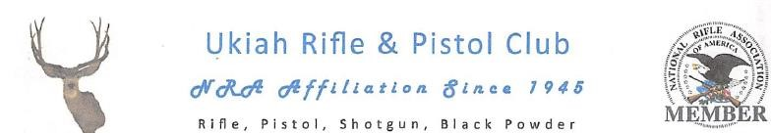

COVID 19 Compliance Plan
The Ukiah Rifle and Pistol Club (URPC) is dedicated to practicing safe recreational firearm and archery activities within the boundaries of the outdoor range complex located at 2200 Vichy Springs Road. URPC is a private firearms recreational facility with membership fees collected on an annual basis normally through the mail. In person transfer of money is rare and, when necessary, normally paid be check in an envelope. When cash is collected, collectors of funds are equipped with personal PPE.
Multiple COVID 19 protocol posters describing best practices are located at the entrance to the property as well as each individual range entrance. The URPC has published and distributed written guidelines to all members describing safe procedures when using range facilities. These procedures include social distancing, masking and the use of sanitizing materials.
Each range is supplied with effective, commercially obtained hand and equipment sanitation products.
There are no employees within the organization. Members of the Board of Directors are elected volunteers and are trained in the use of PPE as described in Mendocino County Health Directives.
On each range, shooting positions are designated and fixed to facilitate safe distancing during the range experience. Members are encouraged to sanitize their shooting position before and after use with the provided sanitizing products. Currently, group activity is prohibited unless safe distancing can be accomplished. For planned activities, reservations are made with the group’s sponsor in an effort to support outside safe distancing.
The current COVID 19 project person is Chief Range Safety Officer Ric Reid (707) 953-6344. The President of the URPC is Joe Nolasco (707) 367-5972.

