HEALTH AND SAFETY PLAN
August 3, 2020

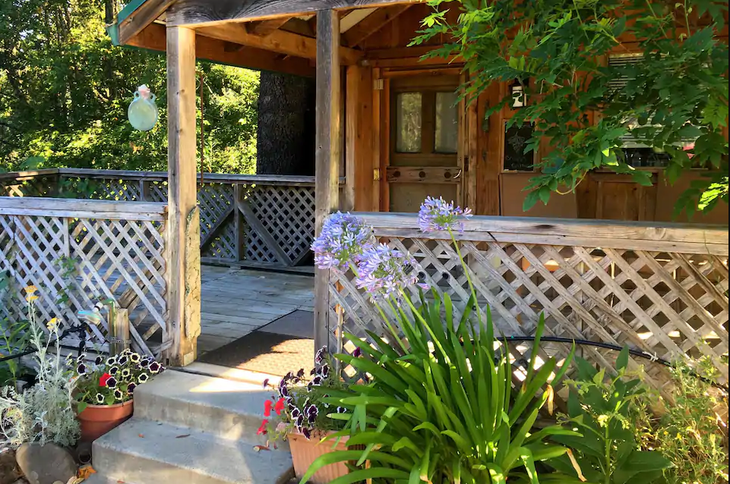

Crispin Cottage
5750 Ruddock Road North
Philo, California 95466

- Type of signage:

Our cottage has a sign on the refrigerator indicating the health and safety measures the onsite host is taking for guests. The sign is attached.

- PPE provided to employees and guests:

The Crispin Cottage has no employees. We have a cleaning person who comes occasionally who has been provided with a cleaning list. The onsite host, Linda, also cleans the cabin. The cleaning instructions provided to them and the property owner (mom) is attached. It tells them when and where to wear gloves and mask, when to wash hands, and provides entire cleaning instructions.

- Employee Training:

We have no employees. As stated above, we have an occasional cleaning person and my mother Linda who cleans. The very specific instructions given to them are attached.

- Protecting employees’ health:

Linda (the property owner) is 81 years old. Protecting her is paramount. We strictly follow the guidelines and insist that the cleaning lady does as well. Additionally, we do not want to be responsible for spreading the virus to the community. We are very sensitive to that and exercise very strict measures of caution.

- Protecting health of guests:

Guests are required to bring their own masks. Onsite hosts have sanitized masks if needed. We do not approach guests. We greet them if there is an opportunity and If they are sociable, distance is respected and masks are worn. The very intense and strict cleaning standards we’ve applied are posted in the cabin, provided to the cleaning person should she be available and followed and enforced by the onsite host.

- Preventing Crowds:

No parties are allowed at our cottage. The cottage can sleep four. We will allow a couple with no more than two children. If a person wants to invite a second friend we will allow that. We don’t allow more than three adults and two children.

- Physical distancing:

So far, we haven’t had to enforce it. All guests have been respectful with masks and distancing. There are no employees and only one cleaning person in the cottage at a time.

- Payment methods:

All payments are received through Airbnb.

- COVID-19 Contacts:

Melanie Ewing 707-895-3291
Jeanette Aiello 808-965-9141
Linda Crispin Hulbert 707-895-3549
Emergency (Medical) 911

All contacts are available at any time.

- Reservation procedure:

All reservations are made online. Jeanette is responsible for scheduling. The cottage is an Airbnb listing.

- Number of Guests Allowed:

Stated above. No more than three adults or a couple and two children.

- Occupancy limit:

Four.

- Hours between guests:

We block a day and a half in between guests to air out the room before we go in to clean, and to clean it. We prefer at least a 24 hour hold. But the way we have it, if a person checks out at noon, they will be checking in at noon the second day after that.

- Describe signed agreement with guests regarding compliance:

The online host (Jeanette), prior to guests stay, inquires with guests what their situation is in terms of the coronavirus in their neighborhood and what they are doing to avoid exposure. Refusal to answer will result in cancelation. The Crispin Cottage currently discourages reservations from out of state and is very concerned with all those coming to stay from anywhere.

- If a guest contracts COVID-19:

If this happens, we will likely not know. The guests will leave and we will not have any clue that they have the virus. They most likely will have come to the cabin with it if this happens. For this reason, our measures presume that all our guests have been exposed. This way, the spread will be avoided. If a guest receives confirmation that they are positive during their stay with us we hope that they will tell us, and will return home to quarantine.

- Sauna, hot tub or steam room.

We have none of the above.

What we are Doing to Keep our Guests Safe

- We keep our distance. Mom will greet you if the opportunity arises. We love socializing with our guests so please don’t be afraid to do that if you wish. We will just don our masks, keep our distance, and enjoy your company.

- We change all the bedding after each stay, not only sheets, but mattress pad, blankets, and bedspread.

- We use disinfectant sanitizer on all counters, the stove, fridge and the entire bathroom.

- We clean the entire floor thoroughly with wood soap safe for the floors, ensuring there are no residues after our guests depart.

- Area rugs vacuumed; sheepskins are replaced between guests. We rest or wash our sheepskins between guests.

- We supply disinfectant surface cleaners for our guests. We supply plenty of paper towels toilet paper and hand soap.

- There will be disinfectant wipes in the cottage. Please use those and the surface cleaner whenever you feel necessary.

- We check to make sure all dishes are washed. Everything in the cupboards are safe.

What we Can’t Do

We’re not sure how to disinfect the couch. We carefully wipe it and the pillows by spraying disinfectant wipe on a towel and wiping the cushions. It’s new and we don’t want to get it wet. Please use caution and respect the safety of our guests.
What we ask of You Currently
- Please put all your towels in the washer. You don’t have to start it but can if you wish. Use judgement on the load.

- Please round up your rubbish and recycles. Please seal the bags as best as you can. If you need supplies to do that, please let mom know. Please put bags out on the porch.

  - We will supply ample garbage bags, including large garbage bags, so our guests can isolate their recyclables and rubbish prior to departure.

LIKE YOU, WE HOPE THAT OUR LIVES WILL SOON RETURN TO NORMAL. WE ARE SO GRATEFUL THAT YOU CHOSE OUR COTTAGE AND HOPE YOU WILL COME AGAIN.
Crispin Cottage Cleaning List
Use mask and gloves for the following (never touch your face unless after washing your hands):
- Start all bathroom and kitchen linens.
- Remove all rubbish and recycles. Seek Linda or Mel’s guidance regarding placement of these items.
- Remove bedding.
- Sheets will go in, time permitting, after towels are done.
- Take blankets and bedspreads to Linda to air on lines or wash as she prefers (Do not shake out).
- Remove mattress pad; replace and launder.
- If any additional bedding has been used, remove, replace and launder.
- Open windows, allow 12-24 hours for cabin to air.
- Use Clorox Clean-up or other disinfectant surface cleaner on Shower, Toilet and Vanity. Thoroughly rinse and wipe dry with rags, your own or provided by Linda.
  - Please wipe or scrub shower thoroughly. Check drain for surface deposits.
  - Clean toilet thoroughly, inside and out. Poor bleach in the bowl to soak. Spray the outside with disinfectant spray all the way to the floor and wipe dry.
  - Mirrors must be spotless.
- Check door full mirror. Clean if necessary.
- Dust end tables, coffee table and dining table with sanitary wipes. Wipe dry.
- Use wood polish on wood surfaces to preserve.
- Wipe dining chairs thoroughly with disinfectant wipes.
- Wash any dishes. If any dishes in cupboards have been used, wash again. Dry and put away.
- Check stove and clean thoroughly; then use disinfectant spray and wipe dry; or use disinfectant wipes then wipe dry.
- Check fridge and cupboards. Throw away anything left.
  - Make sure fridge is clean inside and out. Spray with disinfectant spray. Always wipe everything dry.
- Spray kitchen counters with disinfectant spray. Wipe dry.
- Remove sheepskin rugs from bedroom, give to mom to hang out on the line. Change with replacement sheepskins from mom. Do not shake.
- Vacuum all area rugs. Make SURE they are clean. Do not shake.
- Use Swiffer with wood protectant spray to clean floors thoroughly, or ask mom how to clean the floor.
- Carefully wipe surface of couch. Do not spray. Spray cloth and wipe.
- Clean couch pillows same as number 18.
MOP/VACUUM YOUR WAY OUT OF THE COTTAGE.
- Check sunroom. Vacuum if needed.
- Disinfect/wipe dry porch furniture.
- Sweep porches.

